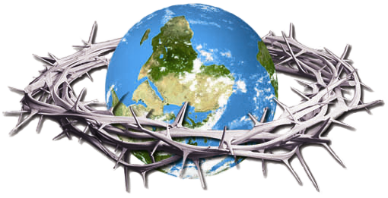
The Crown Of Thorns Project
The Plan For World Evangelism For The SoldOut Movement
“But you will receive power when the Holy Spirit comes on you; and you will be my witnesses in Jerusalem, and in all Judea and Samaria, and to the ends of the earth.” Acts 1:8
“Jerusalem” – Los Angeles
“Judea and Samaria” – United States and Canada
Judea: Albuquerque, Las Vegas, Phoenix, San Diego, Tucson
Samaria: Atlanta, Auburn (2022), Baton Rouge (2022), Boise, Boston, Charlotte, Chicago, Columbus, Dallas/Ft. Worth, Delaware, Denver, Detroit, Eugene, Gainesville, Hilo, Honolulu, Houston, Iowa City (2022), Kansas City (2022), Kona, Indianapolis, Louisville (2022), Miami, Milwaukee, Minneapolis, New Orleans, New York City, Oklahoma City (2022), Orlando, Philadelphia, Providence, Portland (OR), Portland (ME) (2022), Sacramento, Salt Lake City, San Francisco, Seattle, St. Louis, Syracuse, Tallahassee and Thomasville, Tampa, Toronto, Vancouver, Washington DC

OPERATION EAGLE: States Planted 30 / States To Be Planted 20

“To The Ends Of The Earth”
SoldOut Movement – 50 Total Nations
PLANTED NATIONS 32 / REMNANT GROUPS 18 / NATIONS TO BE PLANTED 92
(Nations with a city of a metro population of 1,000,000 or more)
Phase One: Plant The Crown Of Thorns Churches
Santiago  (2009)  London  (2010)  São Paulo  (2011)  Mexico City  (2012) | Paris  (2012)  Sydney  (2014)  Chennai  (2014)  Moscow  (2015) | Manila  (2015)  Lagos  (2016)  Dubai  (2016)  Hong Kong  (2017)

Phase Two: Crown Of Thorns Churches Target Surrounding Nations
Afghanistan, Albania, Algeria, Angola, Argentina, Armenia, Australia, Austria, Azerbaijan, Bahrain, Bangladesh, Belarus, Belgium, Benin, Blue Camel #2, Bolivia (2022), Bosnia and Herzegovia, Bulgaria, Burkina Faso, Burundi, Cambodia, Cameroon, Chad, Central African Republic, Colombia, Congo, Costa Rica, Croatia, Cuba, Curaçao, Czech Republic, Democratic Republic Congo (DRC), Denmark, Dominican Republic (DR), Ecuador, Egypt, El Salvador, Estonia, Ethiopia, Fiji, Finland, Georgia, Germany (2022), Ghana, Greece, Guam, Guatemala, Guinea, Haiti, Honduras, Hungary, Iceland, Indonesia, Iran, Iraq, Ireland (2022), Israel, Italy, Ivory Coast, Jamaica, Japan, Jordan, Kazakhstan, Kenya, Laos, Latvia, Lebanon, Liberia, Libya, Madagascar, Malawi, Malaysia, Mali, Moldovia, Mongolia, Morocco (2022), Mozambique, Myanmar, Nepal, Netherlands, New Guinea, New Zealand, Nicaragua, Niger, North Korea, North Macedonia, Norway, Oman, Pakistan, Panama, Paraguay, Peru, Poland, Portugal, Qatar (2022), Republic of Congo, Romania, Samoa, Scotland, Senegal, Serbia, Sierra Leone, Singapore, Slovakia, Slovenia, Somalia, South Africa, South Korea, Spain, Sri Lanka, Sudan, Sweden (2022), Switzerland, Syria, Taiwan (2022), Tanzania, Thailand, Togo, Tunisia, Turkey, Turkmenistan, Uganda (2022), Ukraine, Uruguay, Uzbekistan, Venezuela, Vietnam, Yemen, Zambia, Zimbabwe
Phase Three: Country’s Pillar Church Evangelizes Their Nation
Brazil (3), Blue Camel (2), Crouching Tiger (2), Democratic Republic of Congo (4), England (2), Haiti (11),
India (4), Ivory Coast (2), Mexico (2), Philippines (7), Russia (2)
(Green – Church Plantings Purple – Remnant Groups Red – To Be Planted)

